


Flash 8

Skills Checklist 2 – Layers and Frames

11. Layers
a | Add a layer by clicking on the Insert Layer button
b | Rename a layer by double clicking on its existing name
c | Objects can only be added to the selected layer
d | Delete a layer by clicking on the Delete Layer button, which looks like a dustbin
e | Hide a layer by clicking on the dot for that layer under the eye, thereby changing the dot into a red ‘X’
f | Reveal a hidden layer by clicking on the red ‘X’ for that layer
g | Reveal all layers by clicking on the eye until all the red ‘X’ symbols become dots
h | You can lock a layer to ensure that it cannot be changed
i  * | Layers at the top of the list will also be highest on the Stage. Rearrange layer order by dragging individual layers up or down into position.
j | N.B. Every animated component in a movie must have its own layer

12. Advanced Layer Features (will be covered later in the course)
a | A Guide Layer can be created to insert a motion path for any motion tween.
b | A Guide Layer can also be created to insert a picture that you would like to trace
c | A Mask Layer combines with another layer to create a Mask or Spotlight effect
d | A group of layers can be organised into a folder when the number of layers starts to become too large.

13. Frames
a | Flash has 2 types of frames – Keyframes and Frames
b | Keyframes are represented in the Timeline as circles
c | Frames have identical content to the keyframe that precedes them
d | The last frame in a series of identical frames is represented by a rectangle.
e | Whichever frame you are working in appears highlighted in black. This is referred to as the ‘Selected Frame’.
f | Insert a frame by right clicking on the chosen frame on the selected layer, and choosing Insert Frame. (shortcut F5)

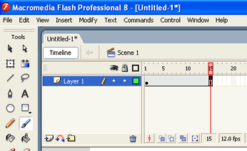

g | Insert a Blank Keyframe by right clicking on the chosen frame on the selected layer, and choosing Insert Blank Keyframe. Extra frames are automatically inserted up to and including the frame immediately preceding the new blank keyframe.
h | A Blank Keyframe is represented by an empty circle.
i | A Blank Keyframe is totally empty. This means that it will have to be filled from scratch.

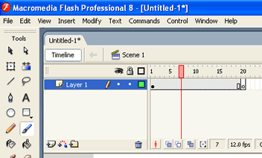

j | Insert a Keyframe by right clicking on the chosen frame on the selected layer, and choosing Insert Keyframe. (shortcut F6)
k | Insert Keyframe automatically copies the contents of the previous keyframe. (Represented by a filled black circle)
l | Extra frames are automatically inserted up to and including the frame immediately preceding the new keyframe.

